VIEW NO. 1

CREATE VIEW [PassengersPerRunningTrain] AS

select TrainSchedule.RunningTrainID, Count(TicketBooking.PassengerID) as NumberofPassenger from TrainSchedule inner join TicketBooking on

TrainSchedule.TrainScheduleID = TicketBooking.SourceTrainScheduleID

Group By RunningTrainID

SELECT * FROM PassengersPerRunningTrain

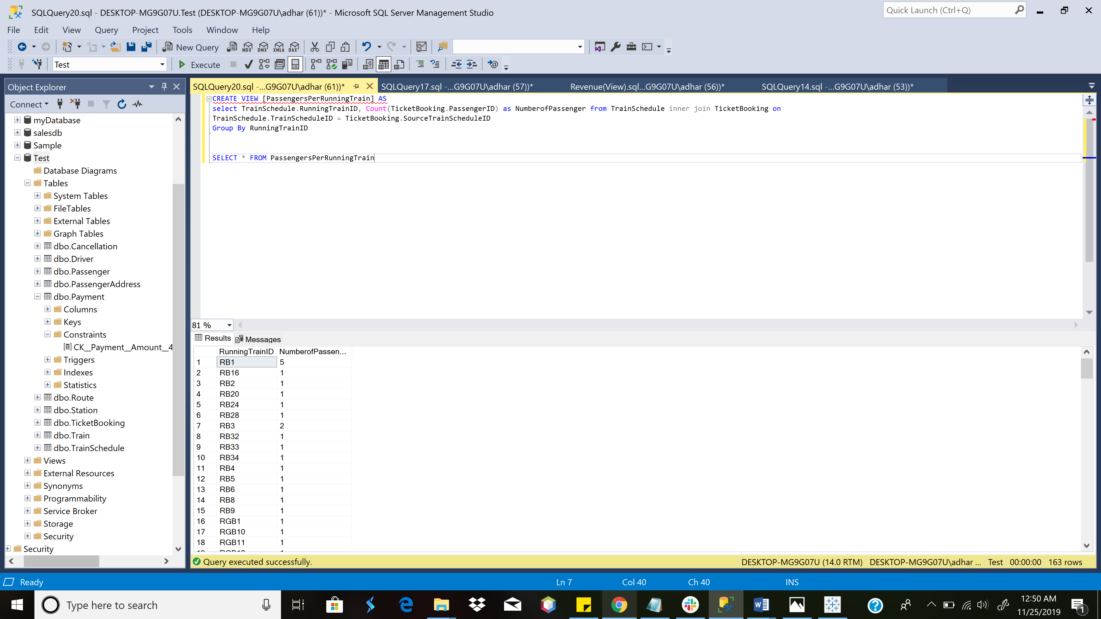

VIEW [PassengersPerRunningTrain]

View No. 2

CREATE VIEW [Revenue by Route] AS

SELECT RouteID, Count(p.BookingID)*2.5 AS Revenue from Payment p inner join TicketBooking t

on p.BookingID = t.BookingID

GROUP BY RouteID

SELECT * From [Revenue by Route]

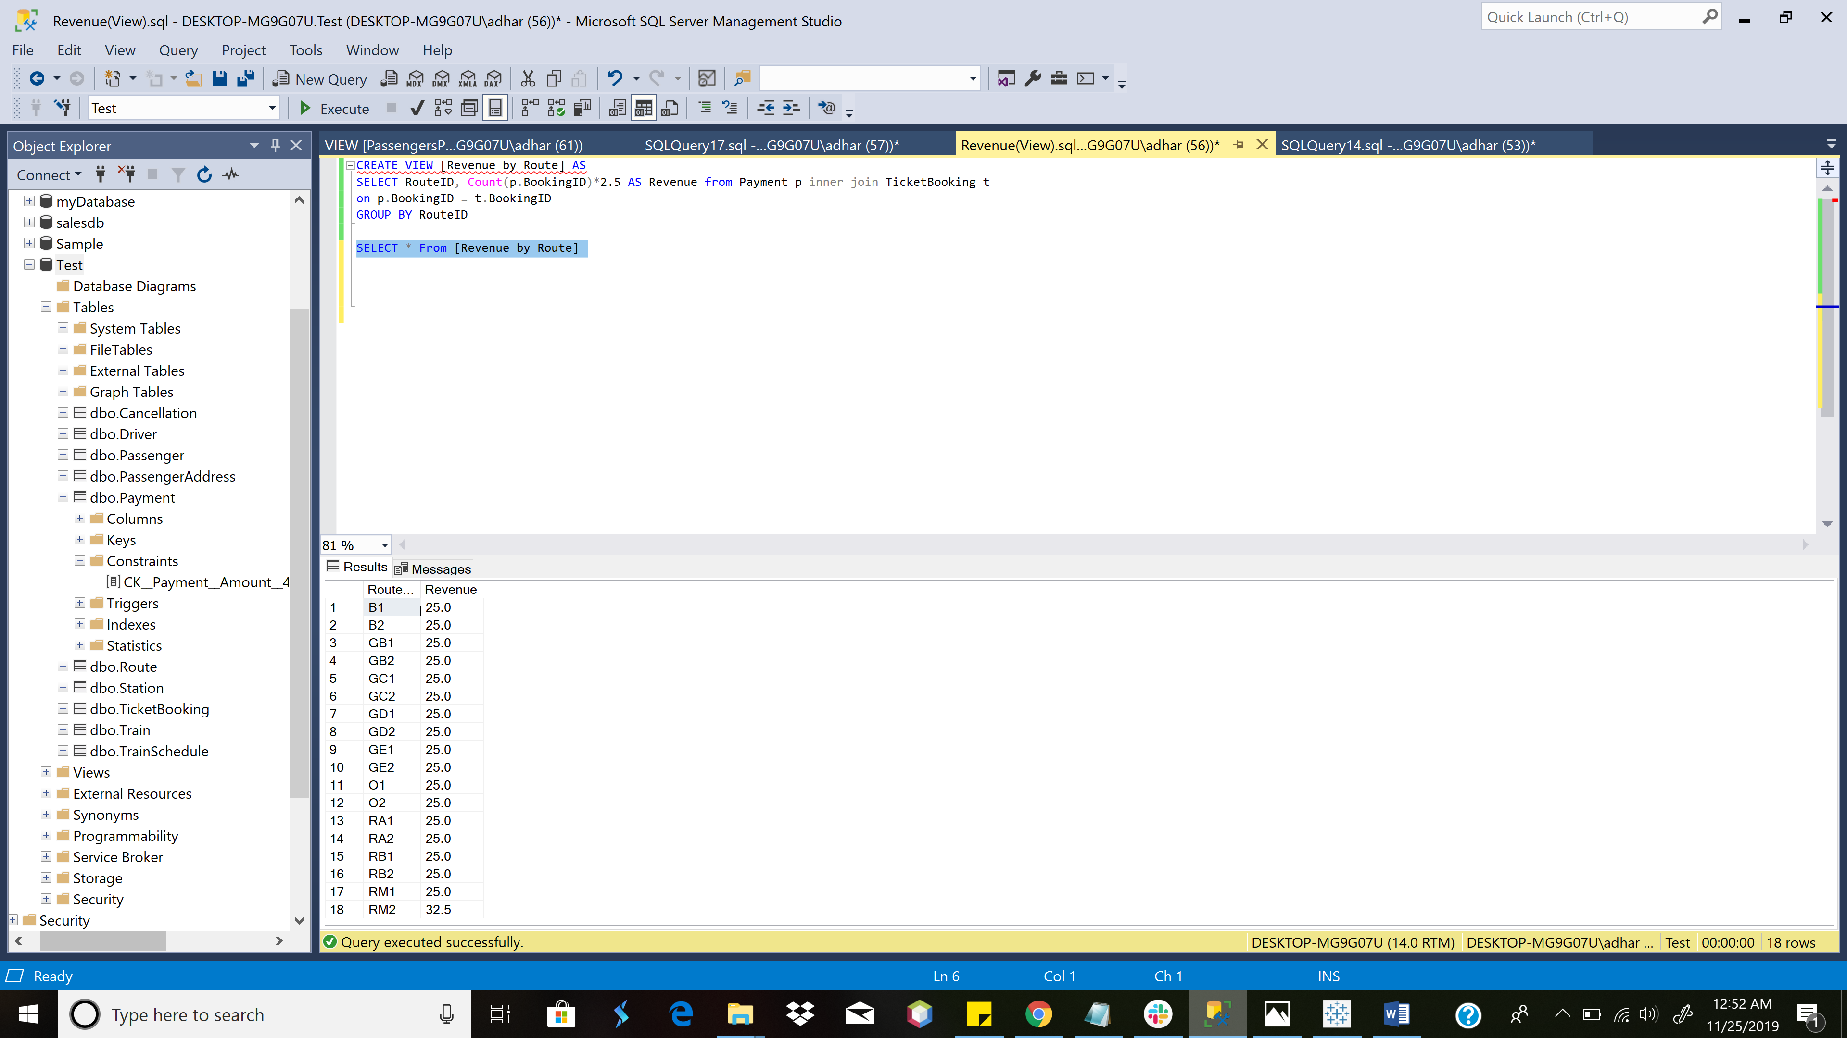

VIEW [Revenue Per Route]

Column Data Encryption

USE master;

GO

SELECT *

FROM sys.symmetric_keys

WHERE name = '##MS_ServiceMasterKey##';

GO

-- Create database Key

USE Test;

GO

CREATE MASTER KEY ENCRYPTION BY PASSWORD = 'Password123';

GO

-- Create self signed certificate

USE Test;

GO

CREATE CERTIFICATE Certificate1

WITH SUBJECT = 'Protect Data';

GO

-- Create symmetric Key

USE Test;

GO

CREATE SYMMETRIC KEY SymmetricKey1

WITH ALGORITHM = AES_128

ENCRYPTION BY CERTIFICATE Certificate1;

GO

USE Test;

GO

ALTER TABLE Payment

ADD Credit_card_number_encrypt varbinary(MAX) NULL

GO

-- Populating encrypted data into new column

USE Test;

GO

-- Opens the symmetric key for use

OPEN SYMMETRIC KEY SymmetricKey1

DECRYPTION BY CERTIFICATE Certificate1;

GO

UPDATE Payment

SET Credit_card_number_encrypt = EncryptByKey (Key_GUID('SymmetricKey1'),CardNumber)

FROM Payment;

GO

-- Closes the symmetric key

CLOSE SYMMETRIC KEY SymmetricKey1;

GO

SELECT * FROM Payment

USE Test;

GO

ALTER TABLE Customer_data

DROP COLUMN Credit_card_number;

GO

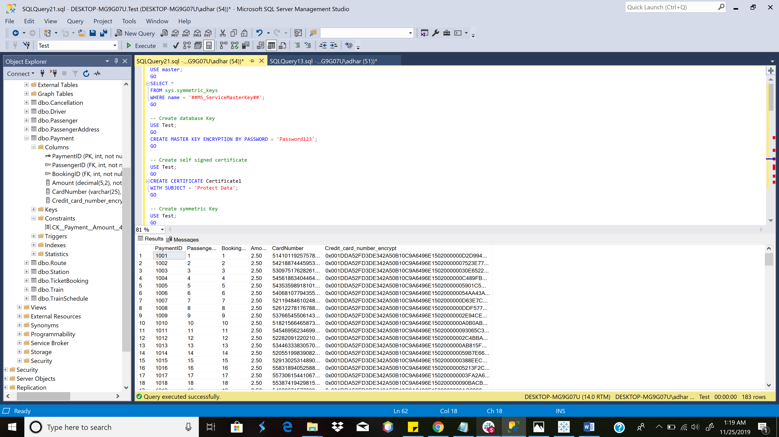

COLUMN DATA ENCRYPTION

Computed Columns based on a Function

ALTER TABLE Passenger ADD CurrentAge AS DATEDIFF(YEAR, DateofBirth, GETDATE())

SELECT * FROM Passenger

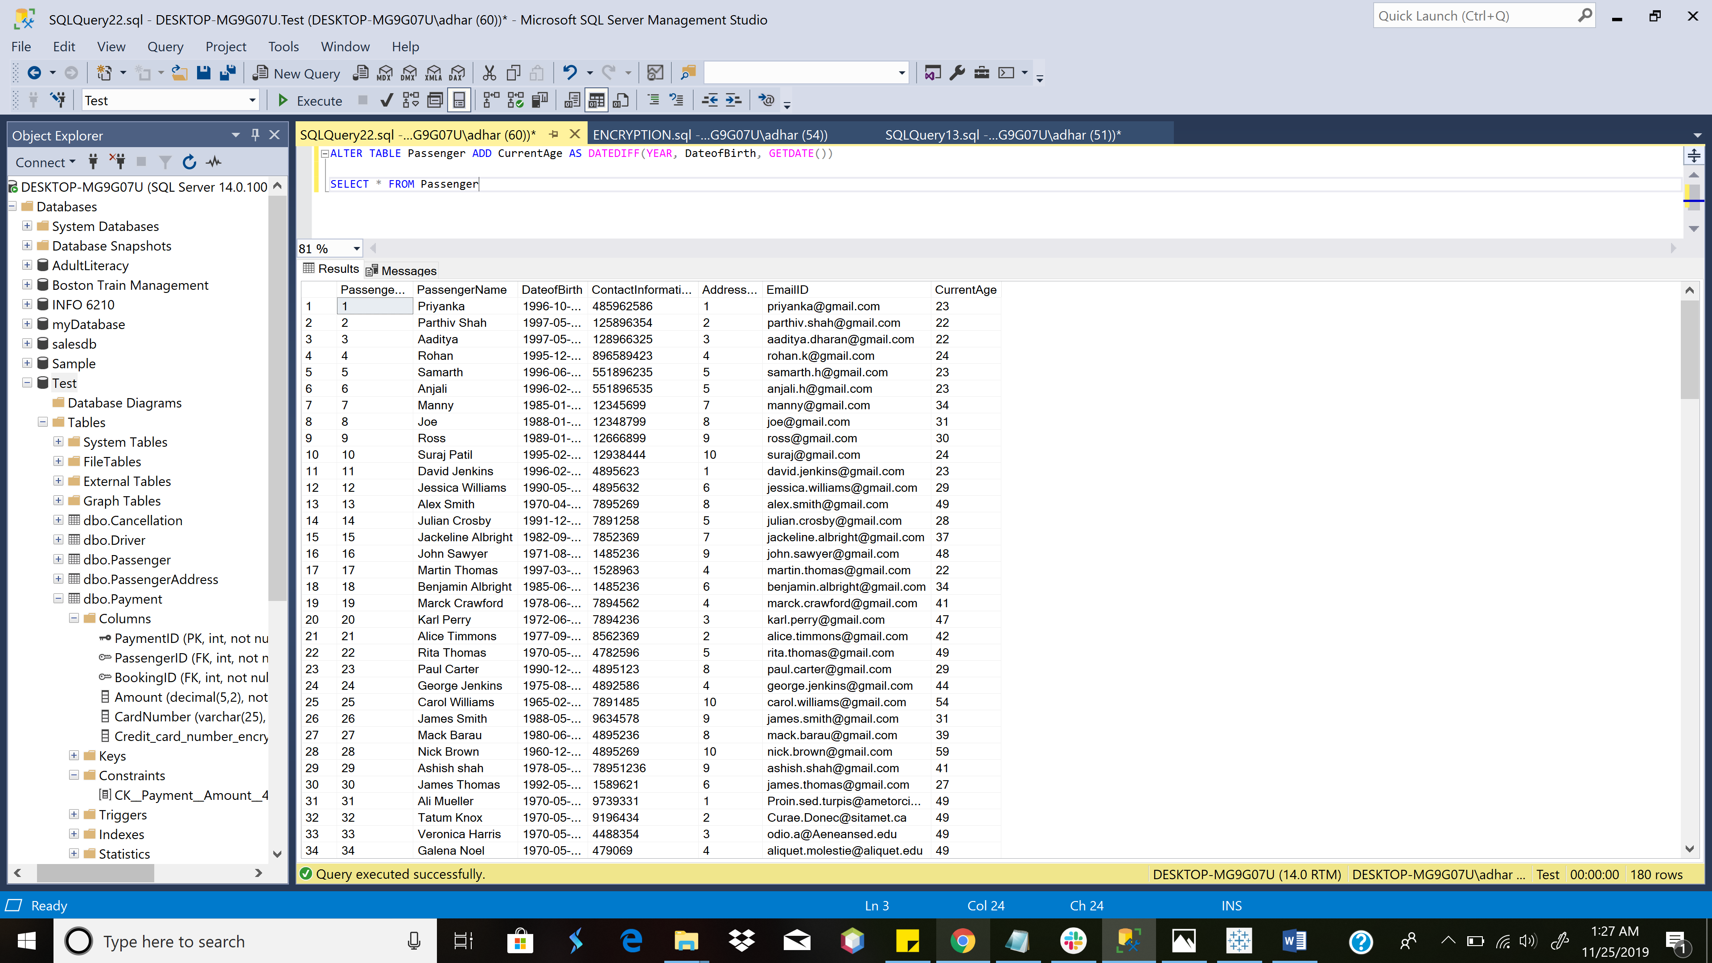

Computed Columns [based on a Function]

TABLE LEVEL CHECK CONSTRAINT

ALTER TABLE Payment ADD CHECK (Amount = 2.50)

INSERT INTO Payment values (1234, 4, 5000, 2.00, 22222222222)

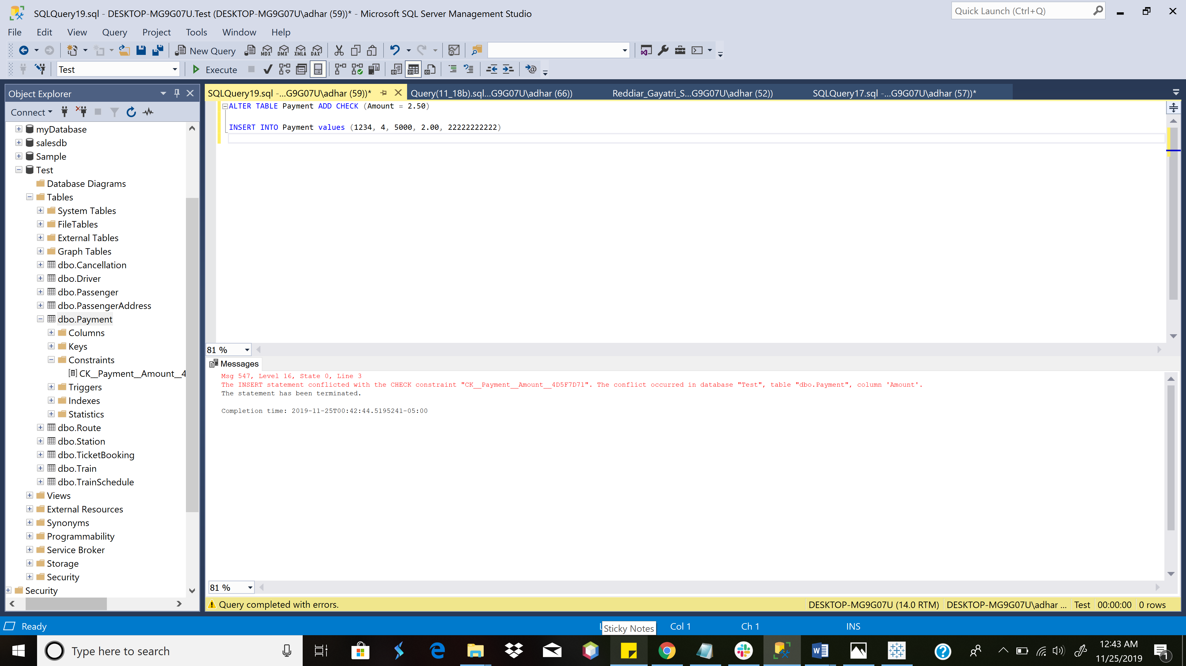

TABLE LEVEL CHECK CONSTRAINT ON PAYMENT TABLE

STORED PROCEDURE TrainSchedule OUTBOUND

CREATE PROCEDURE TrainScheduleOutbound @Source VARCHAR(25), @Destination VARCHAR(25), @StartTime TIME, @EndTime TIME

AS

BEGIN

SELECT t1.trainID, s1.StationName,t1.Arrival, s2.StationName, t1.[Date]

FROM TrainSchedule t1 inner join TrainSchedule t2 on t1.RunningTrainID = t2.RunningTrainID and t1.RouteID = t2.RouteID

inner join Station s1 on s1.StationStopID=t1.StationStopID inner join Station s2 on s2.StationStopID=t2.StationStopID

inner join Route r on s1.RouteID=r.RouteID

where (t1.Arrival between @StartTime and @EndTime) and s1.StationName = @Source and s2.StationName=@Destination and (t1.RouteID='GE1' OR t1.RouteID='GD1' OR t1.RouteID='GC1' OR t1.RouteID='GB1'

OR t1.RouteID='B1' OR t1.RouteID='RA1'OR t1.RouteID='O1'OR t1.RouteID='RB1' OR t1.RouteID='RM1')

END

EXECUTE TrainScheduleOutbound

@Source = 'Prudential'

, @Destination = 'North Station'

, @StartTime = '15:00'

, @EndTime = '19:00'

GO

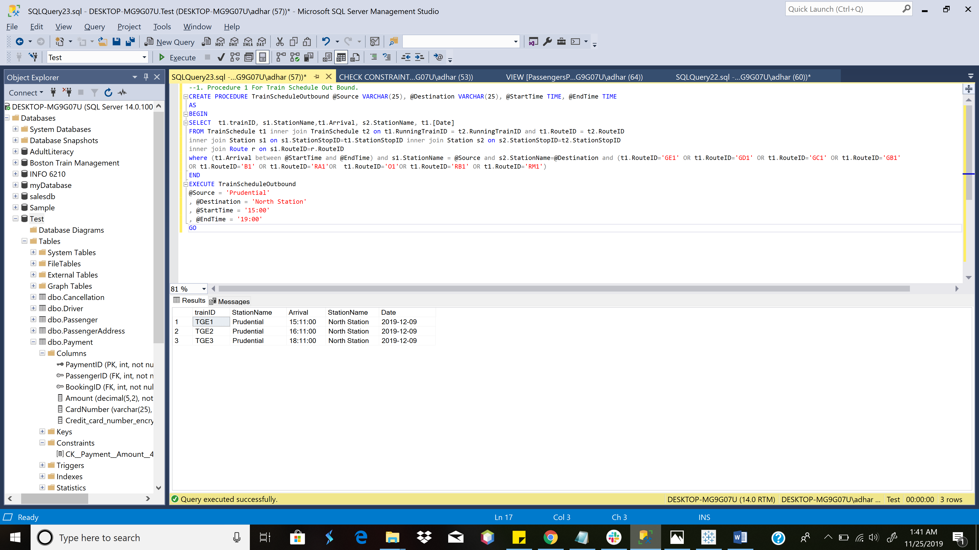

Stored Procedure For Train Schedule Out Bound

STORED PROCEDURE TrainSchedule Inobund

CREATE PROCEDURE TrainScheduleInbound @Source VARCHAR(25), @Destination VARCHAR(25), @StartTime TIME, @EndTime TIME

AS

BEGIN

SELECT t1.trainID, s1.StationName,t1.Arrival, s2.StationName, t1.[Date]

FROM TrainSchedule t1 inner join TrainSchedule t2 on t1.RunningTrainID = t2.RunningTrainID and t1.RouteID = t2.RouteID

inner join Station s1 on s1.StationStopID=t1.StationStopID inner join Station s2 on s2.StationStopID=t2.StationStopID

inner join Route r on s1.RouteID=r.RouteID

where (t1.Arrival between @StartTime and @EndTime) and s1.StationName = @Source and s2.StationName=@Destination and (t1.RouteID='GE2' OR t1.RouteID='GD2' OR t1.RouteID='GC2' OR t1.RouteID='GB2'

OR t1.RouteID='B2' OR t1.RouteID='RA2'OR t1.RouteID='O2'OR t1.RouteID='RB2' OR t1.RouteID='RM2')

END

EXECUTE TrainScheduleInbound

@Source = 'Kenmore'

, @Destination = 'Boston University West'

, @StartTime = '15:00'

, @EndTime = '19:00'

GO

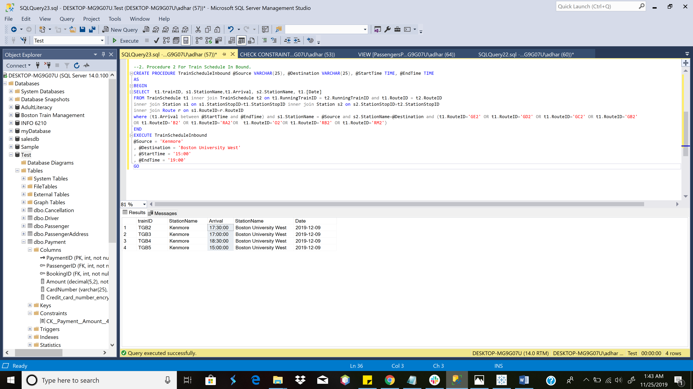

Stored Procedure For Train Schedule InBound

Stored Procedure to add Passenger Details

CREATE PROCEDURE AddPassengerDetails @passengerID int, @passengerName varchar(25), @DOB date, @contactInfo int, @addressID int, @emailID VARCHAR(225), @address VARCHAR(255), @state VARCHAR(225), @country VARCHAR(225), @zipcode int

AS

BEGIN

INSERT INTO PassengerAddress(AddressID,[Address],[State],Country,ZipCode) VALUES (@addressID, @address ,@state, @country, @zipcode);

INSERT INTO Passenger(PassengerID,PassengerName,DateOfBirth,ContactInformation,AddressID,EmailID) VALUES (@passengerID, @passengerName, @DOB, @contactInfo,@addressID,@emailID);

SELECT * FROM Passenger

END

EXECUTE AddPassengerDetails

@passengerID = 182

,@passengerName = 'Milan Yewale'

,@DOB = '1996-12-12'

,@contactInfo = 13847333

,@addressID = 111

,@emailID = 'ry@gmail.com'

,@address='69 South Huntington'

,@state= 'MA'

,@country= 'USA'

,@zipcode = 02130

PRINT('Passenger Details added successfully!')

GO

SELECT * FROM PassengerAddress

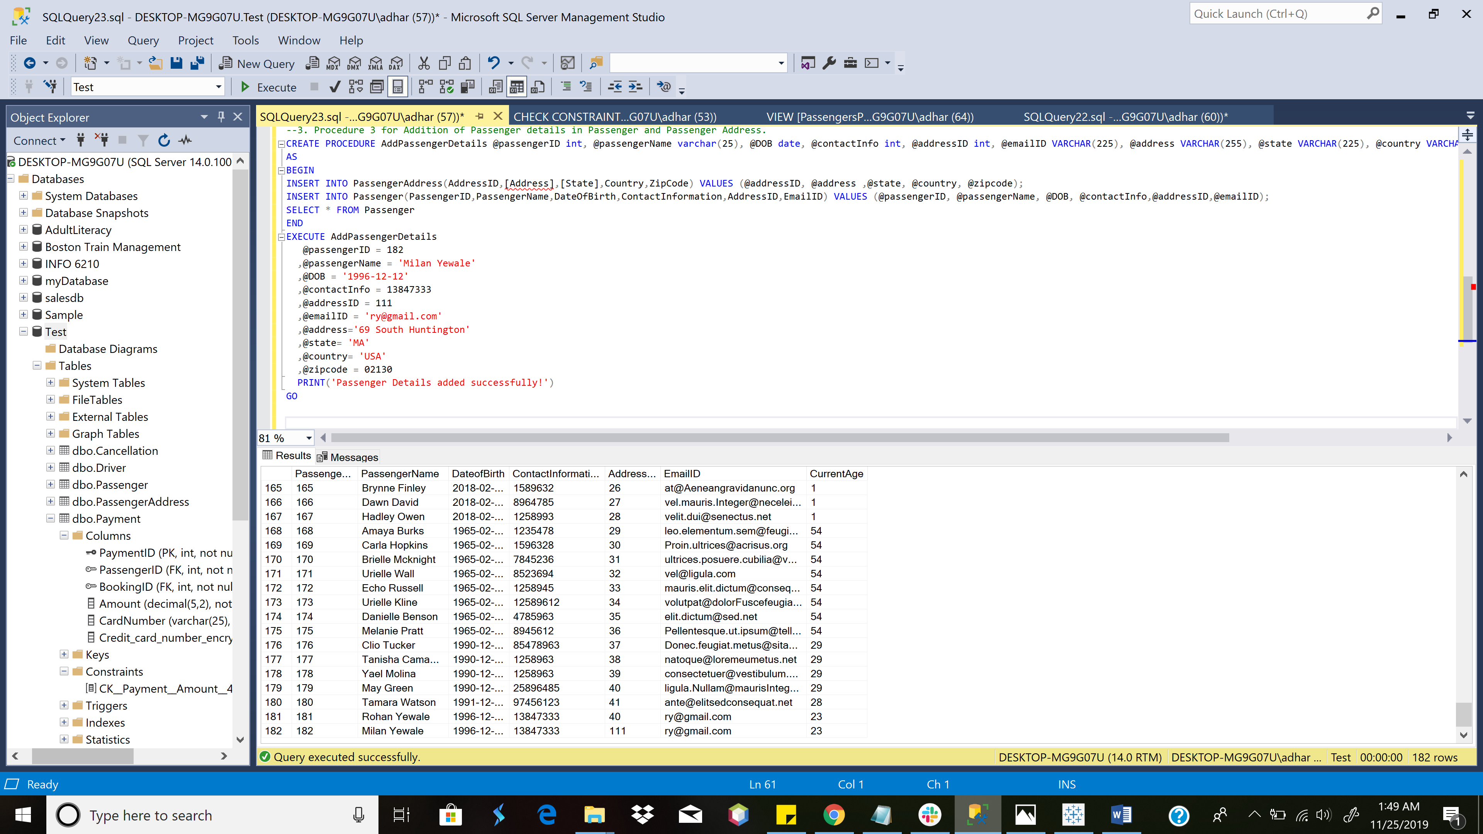

Screenshot of added Passenger Details in Passenger Table

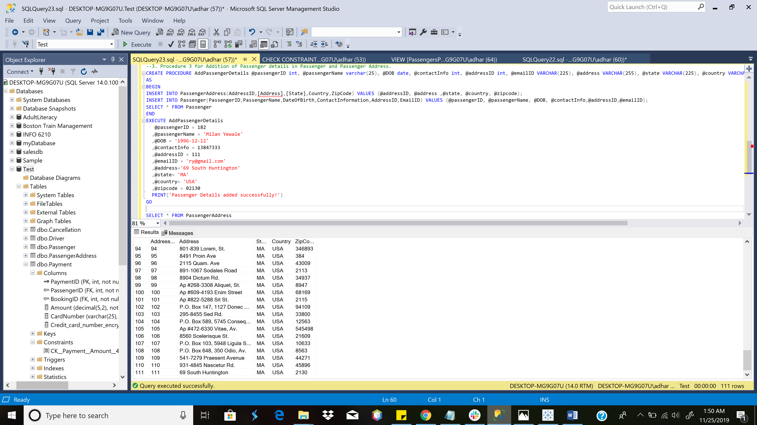

Screenshot of added Passenger Details in PassengerAddress Table using Same Stored Procedure

Stored Procedure to get Reaching Time at Desired Location

CREATE PROCEDURE ReachingTimeForDesiredDestination @SOURCE VARCHAR(50), @DESTINATION VARCHAR (50), @RunningTrainID VARCHAR (20)

AS

BEGIN

SELECT TrainID,RunningTrainID, s.StationName, Arrival,

( select Arrival from Station join TrainSchedule on Station.StationStopID=TrainSchedule.StationStopID where (StationName=@DESTINATION and RunningTrainID =@RunningTrainID)) as ReachingTimeAtDesiredDestination

FROM TrainSchedule t INNER JOIN Station s on

t.StationStopID=s.StationStopID where (s.StationName = @SOURCE ) and (RunningTrainID = @RunningTrainID)

END

EXECUTE ReachingTimeForDesiredDestination

@SOURCE = 'Davis',

@DESTINATION ='Park Street',

@RunningTrainID = 'RRA3'

GO

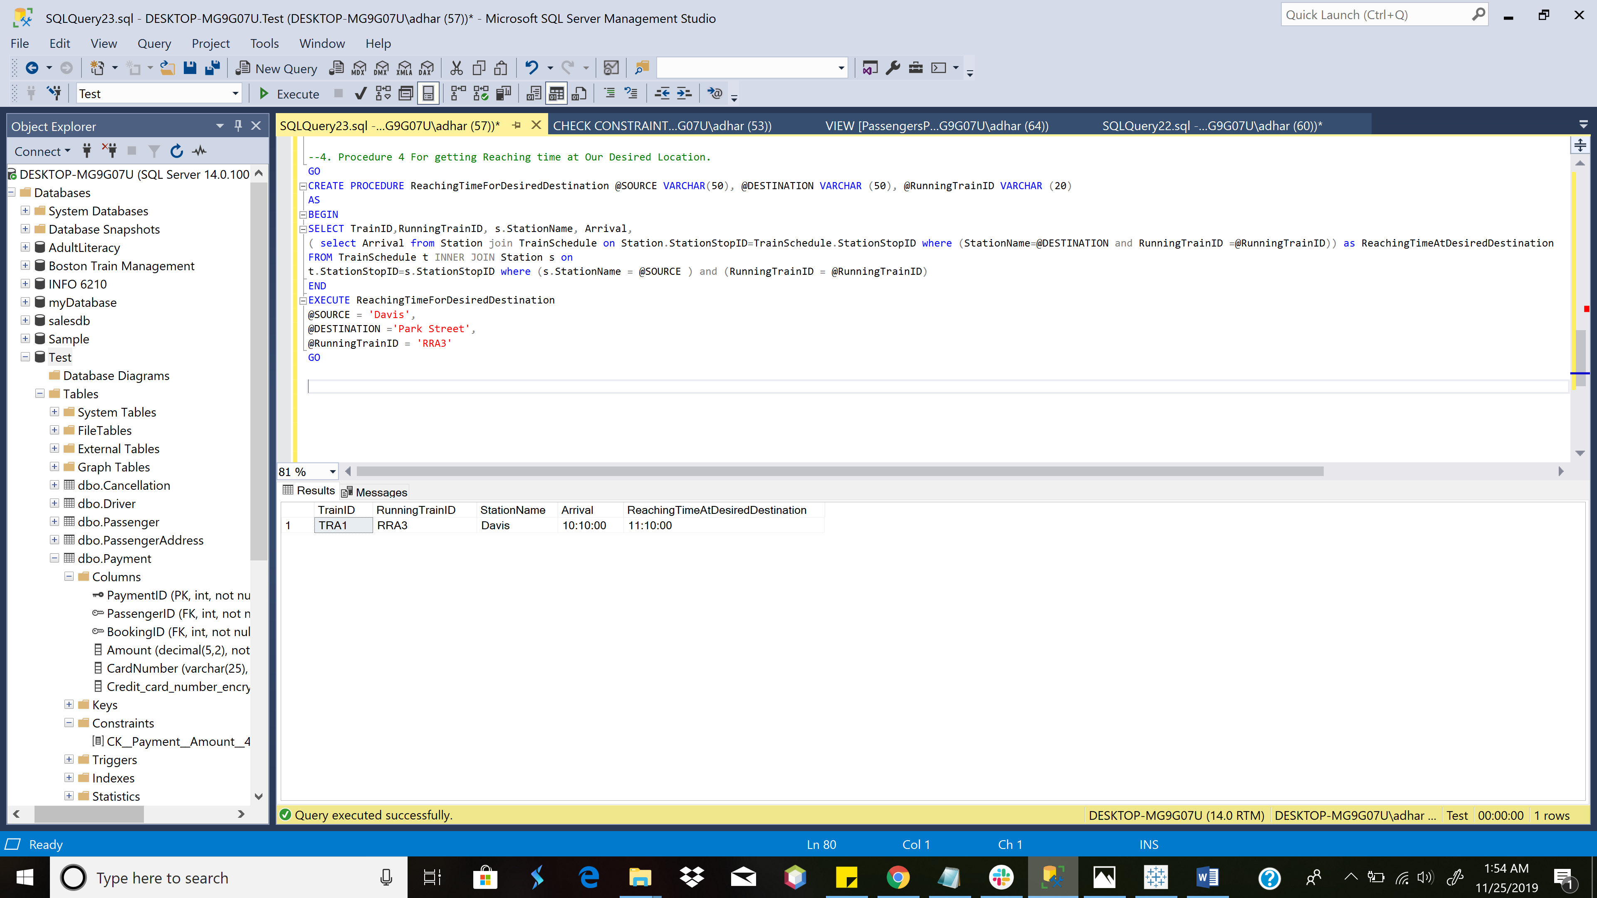

Stored Procedure for getting Detailed Driver Schedule

CREATE PROCEDURE DriverSchedule @DriverID INT

AS

BEGIN

SELECT Driver.DriverID, Driver.DriverName, TrainSchedule.Arrival, TrainSchedule.TrainID, TrainSchedule.RouteID, TrainSchedule.[Date]

FROM Driver INNER JOIN TrainSchedule ON TrainSchedule.DriverID = Driver.DriverID WHERE Driver.DriverID = @DriverID

END

EXECUTE DriverSchedule

@DriverID = 3

GO

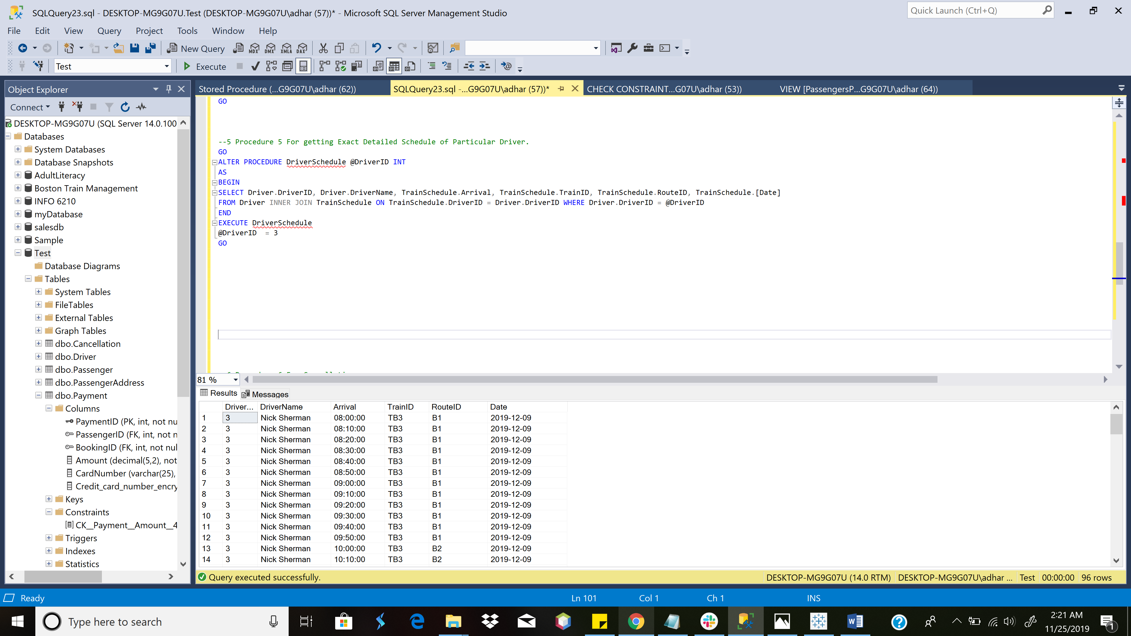

Stored Procedure to obtain Detailed Driver Schedule

TRIGGER [Delay Monitor]

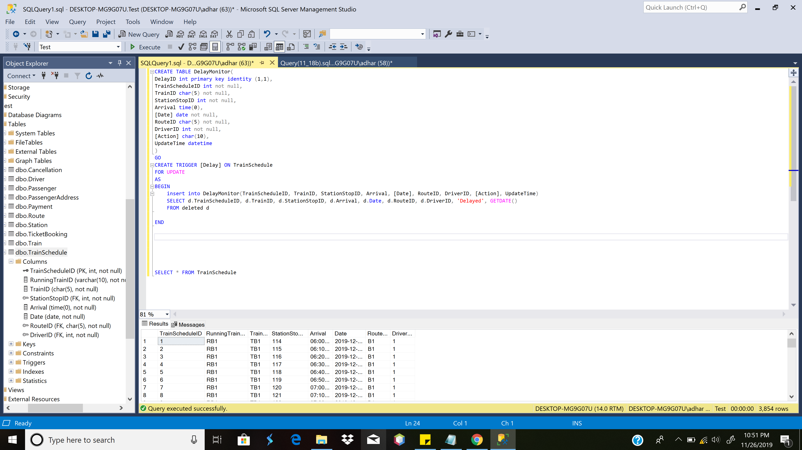

INITIAL TRIGGER

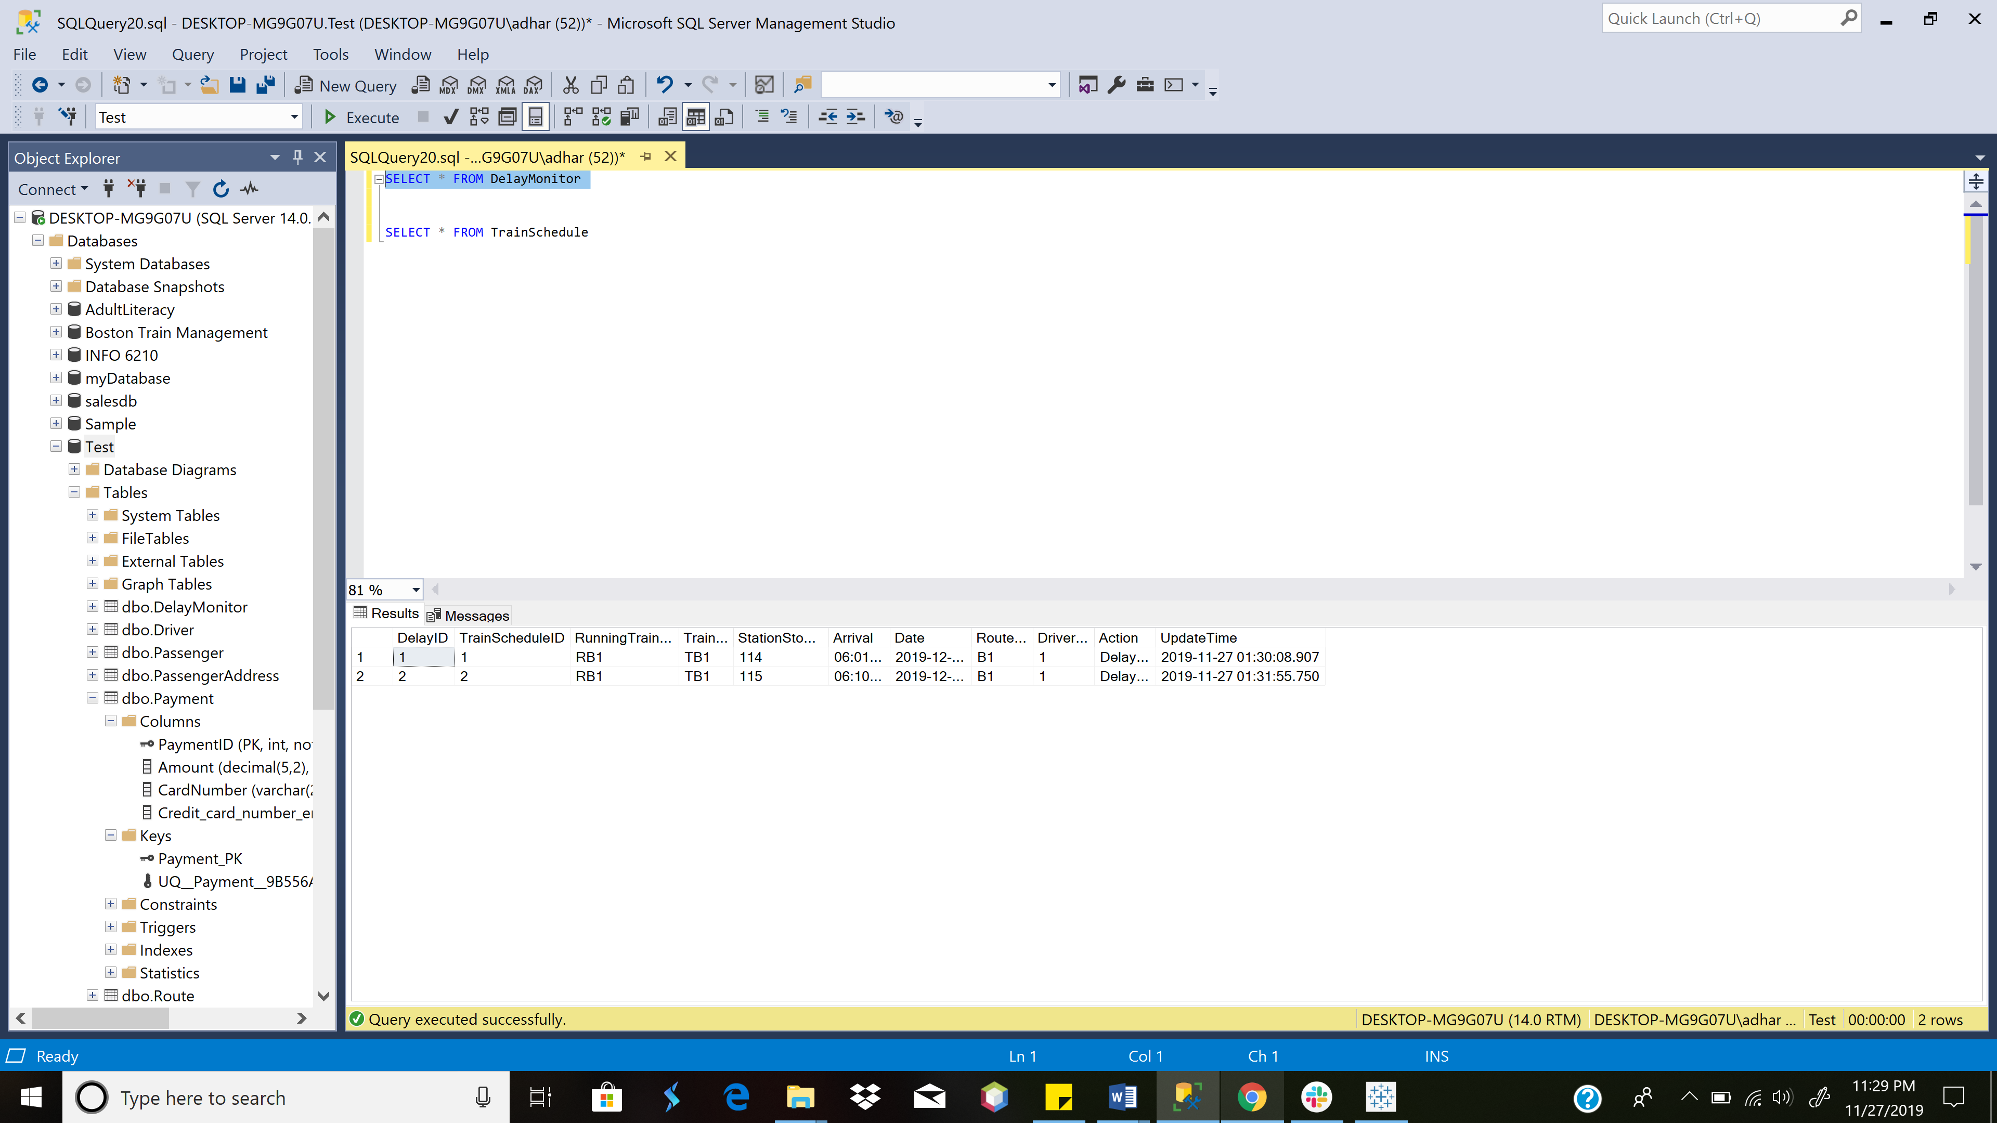

TABLE DelayMonitor

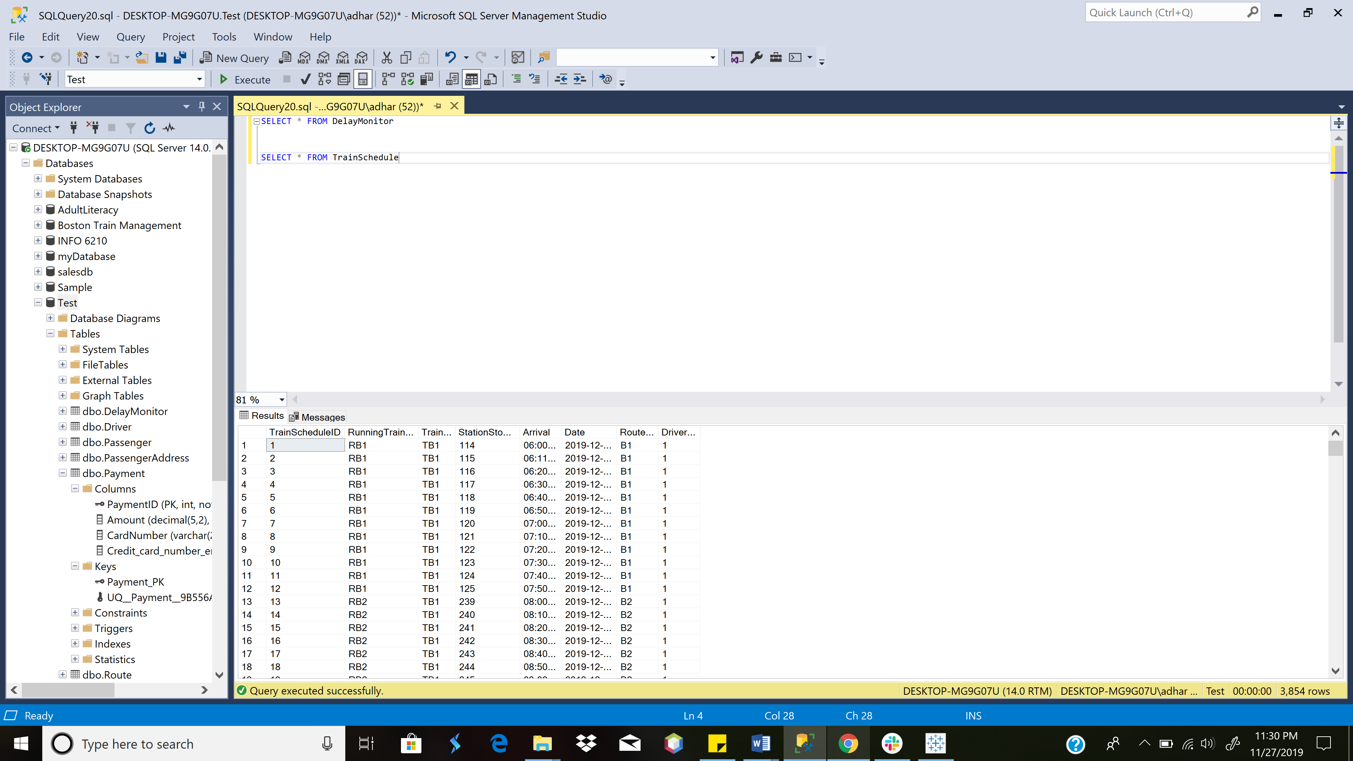

Changes in TrainSchedule (after Trigger)

CREATE TABLE DelayMonitor(

DelayID int primary key identity (1,1),

TrainScheduleID int not null,

RunningTrainID varchar(10) not null,

TrainID char(5) not null,

StationStopID int not null,

Arrival time(0),

[Date] date not null,

RouteID char(5) not null,

DriverID int not null,

[Action] char(10),

UpdateTime datetime

)

GO

ALTER TRIGGER [Delay] ON TrainSchedule

AFTER UPDATE

AS

BEGIN

insert into DelayMonitor(TrainScheduleID, RunningTrainID, TrainID, StationStopID, Arrival, [Date], RouteID, DriverID, [Action], UpdateTime)

SELECT d.TrainScheduleID, d.RunningTrainID,d.TrainID, d.StationStopID, d.Arrival, d.Date, d.RouteID, d.DriverID, 'Delayed', GETDATE()

FROM deleted d

END

TRIGGER [Cancellation]

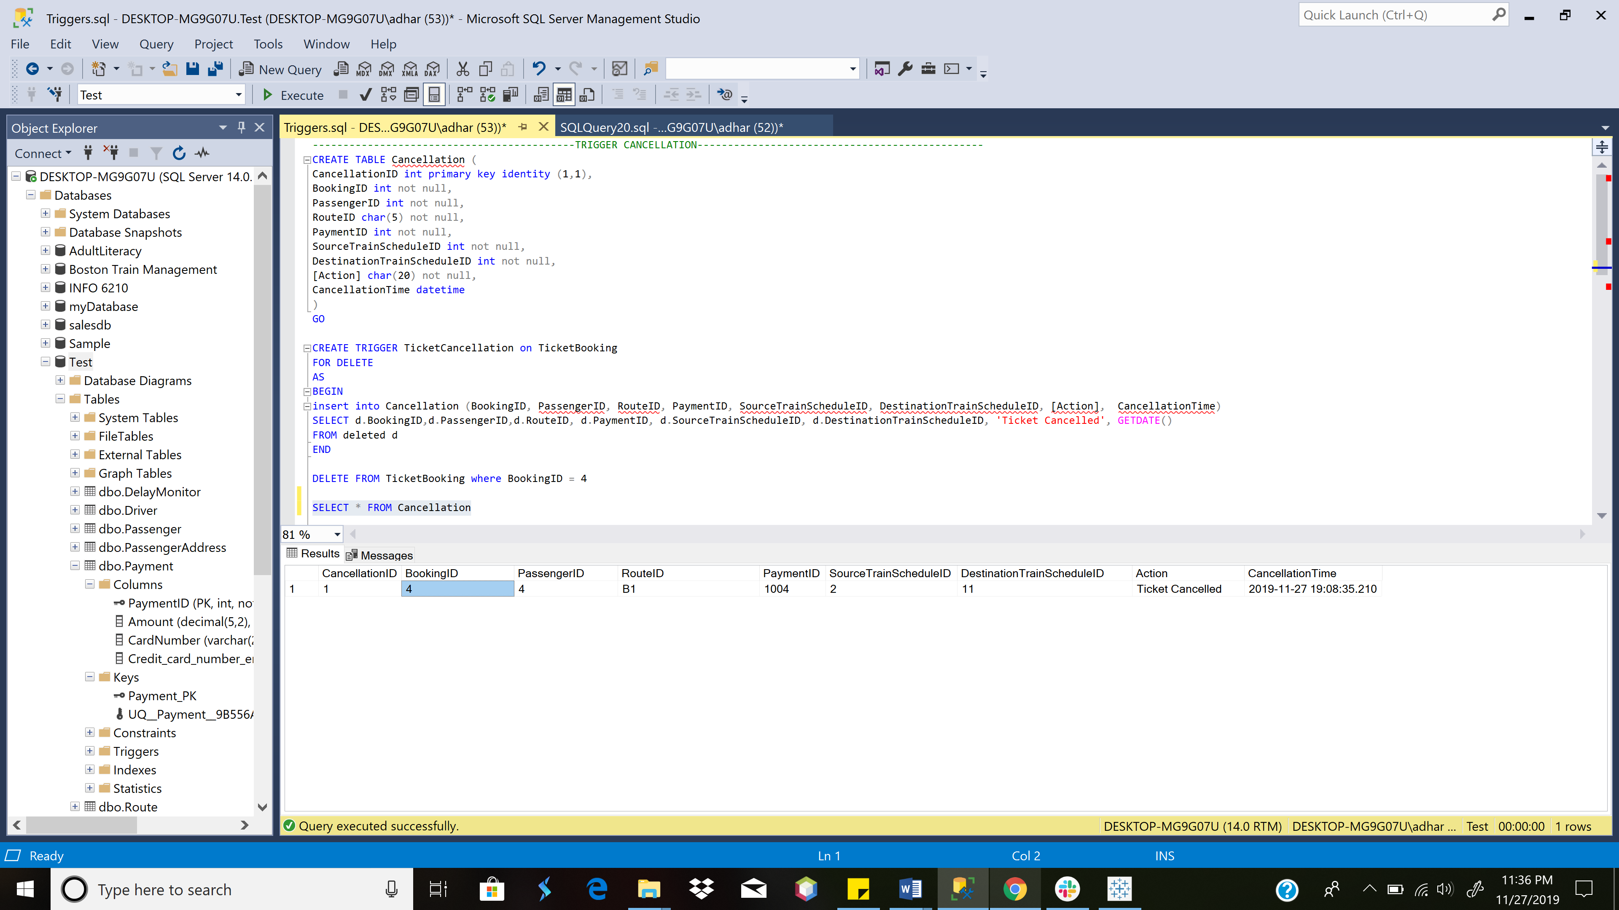

Cancellation Table after TicketCancellation Trigger is fired

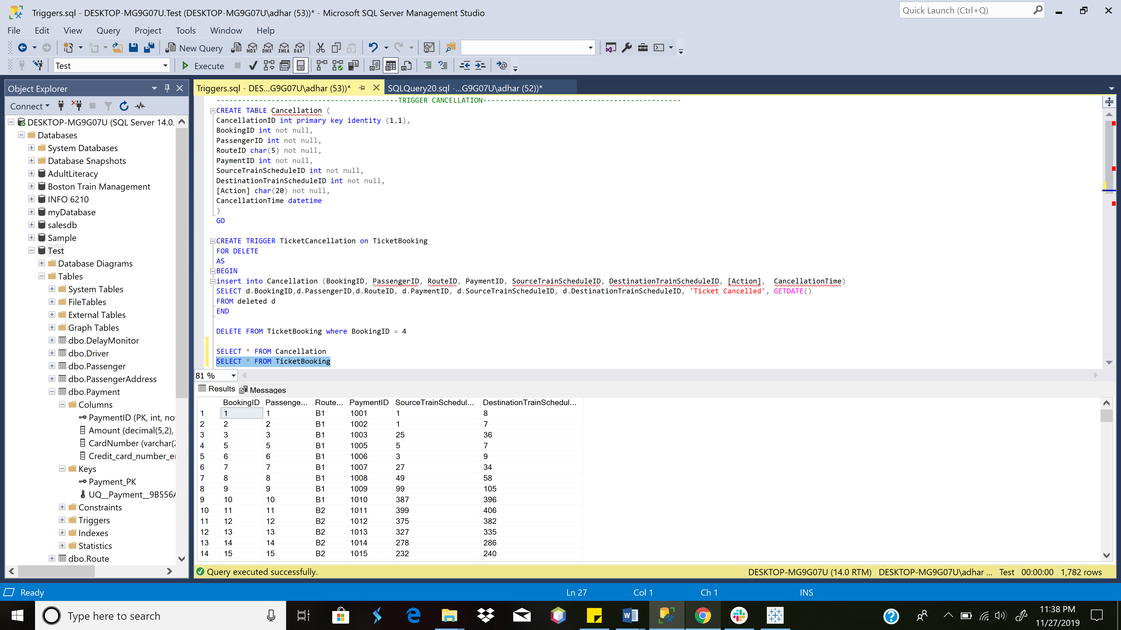

TicketBooking Table after TicketCancellation Trigger is fired

CREATE TABLE Cancellation (

CancellationID int primary key identity (1,1),

BookingID int not null,

PassengerID int not null,

RouteID char(5) not null,

PaymentID int not null,

SourceTrainScheduleID int not null,

DestinationTrainScheduleID int not null,

[Action] char(20) not null,

CancellationTime datetime

)

GO

CREATE TRIGGER TicketCancellation on TicketBooking

FOR DELETE

AS

BEGIN

insert into Cancellation (BookingID, PassengerID, RouteID, PaymentID, SourceTrainScheduleID, DestinationTrainScheduleID, [Action], CancellationTime)

SELECT d.BookingID,d.PassengerID,d.RouteID, d.PaymentID, d.SourceTrainScheduleID, d.DestinationTrainScheduleID, 'Ticket Cancelled', GETDATE()

FROM deleted d

END

DELETE FROM TicketBooking where BookingID = 4

SELECT * FROM Cancellation

SELECT * FROM TicketBooking

-Bar Graph for **Revenue per Train Route** which is further divided into **Individual Running Trains**.

- Pie Chart for **Revenue per Train Route**

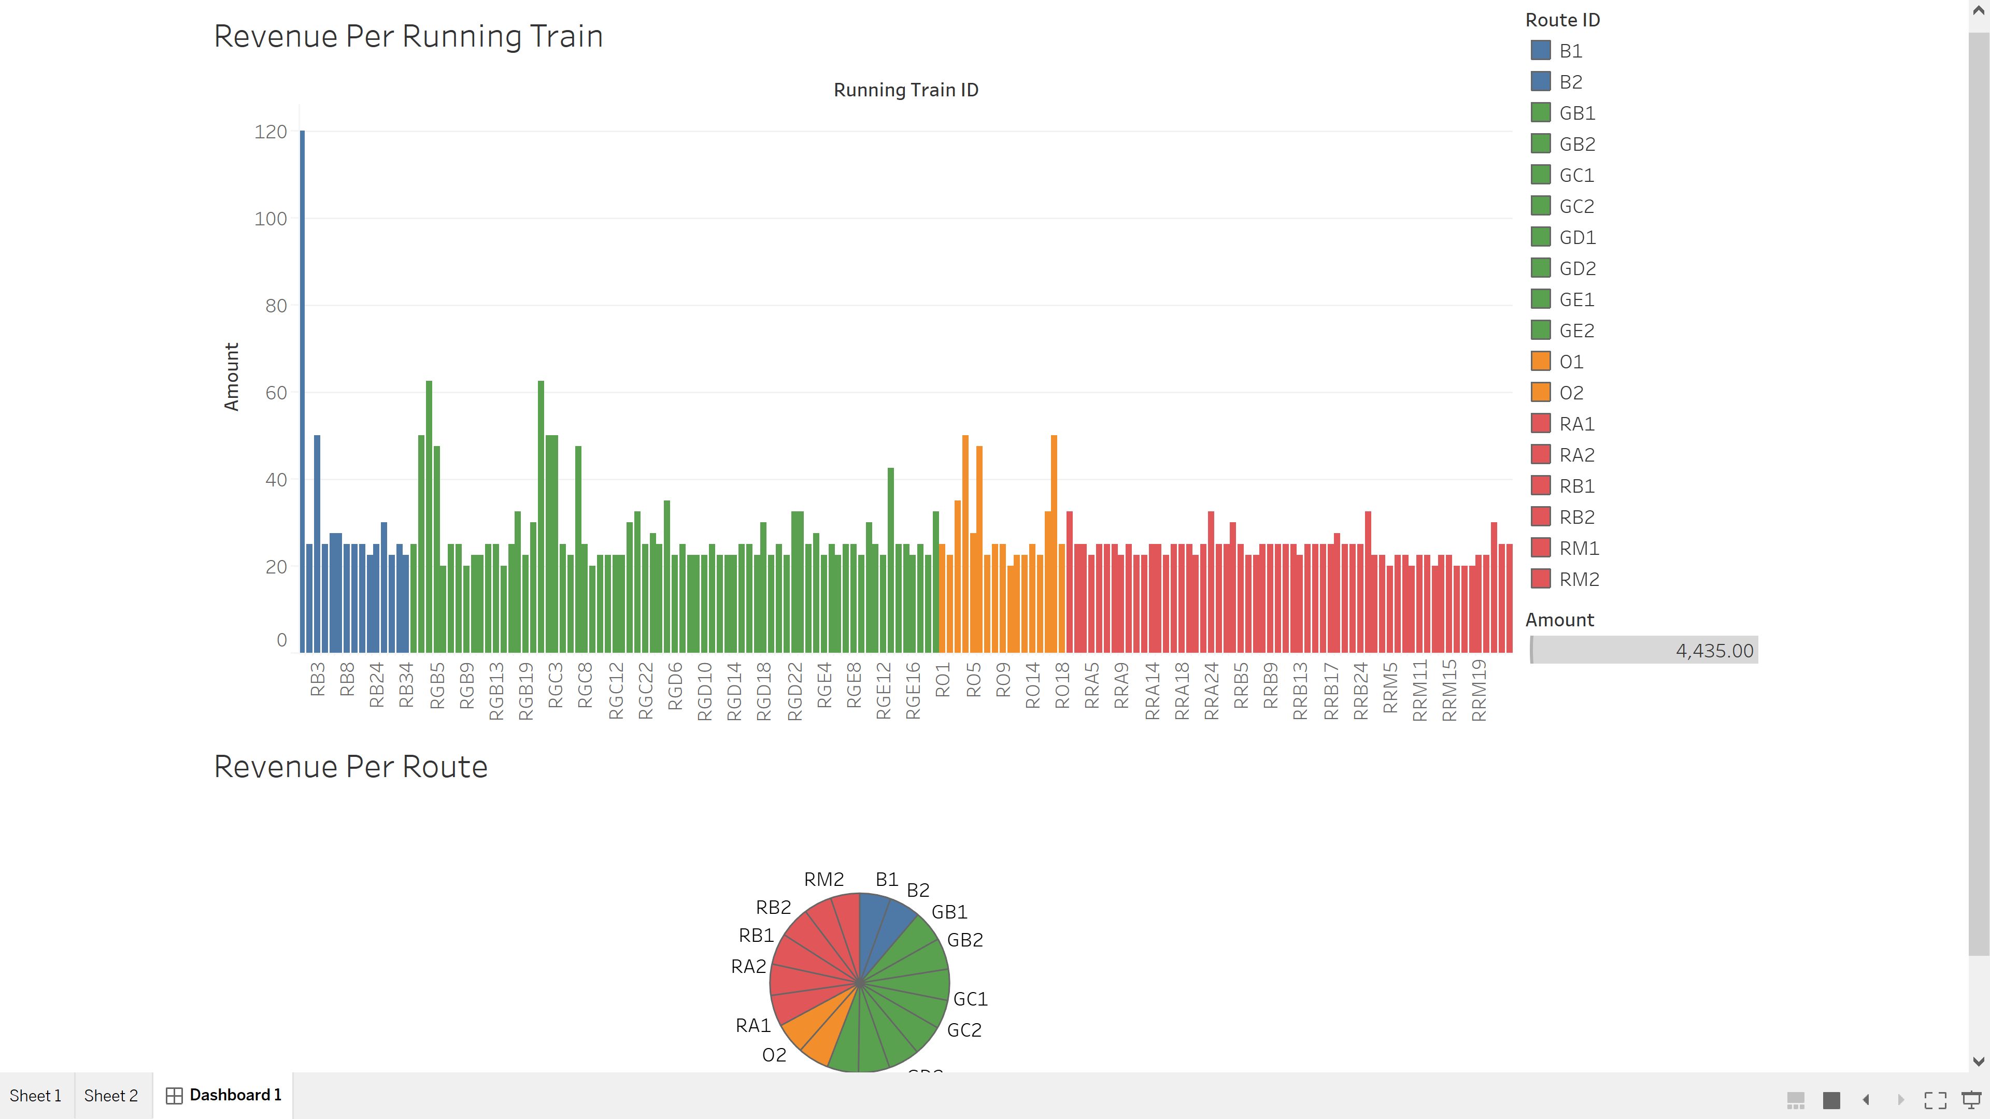

-Bar Graph for **Number of Passengers boarding** at a particular **Station (Over Multiple Lines)**

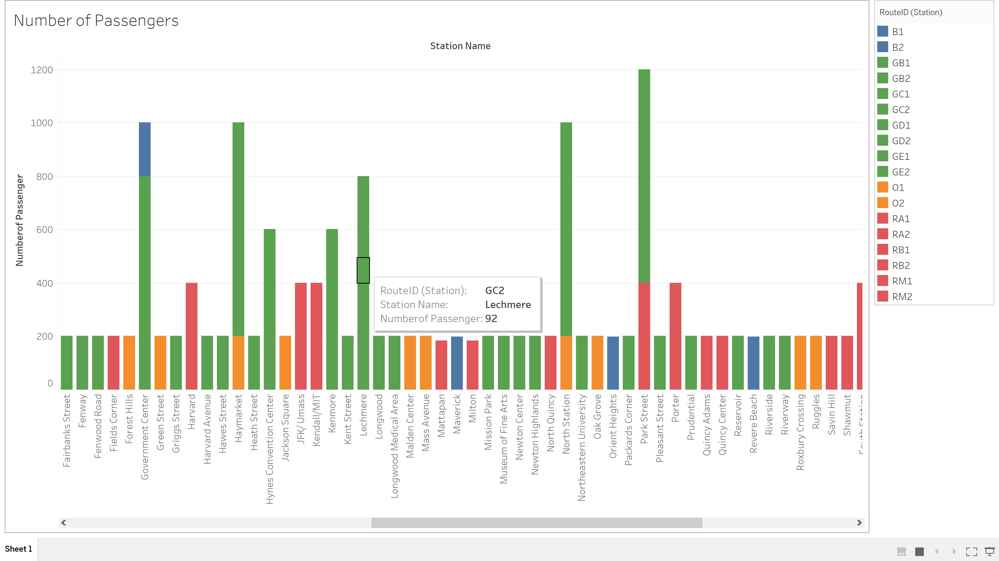

-Bar Graph for **Number of Passengers** at a **particular station(Northeastern)** on a **particular route(GE1)**

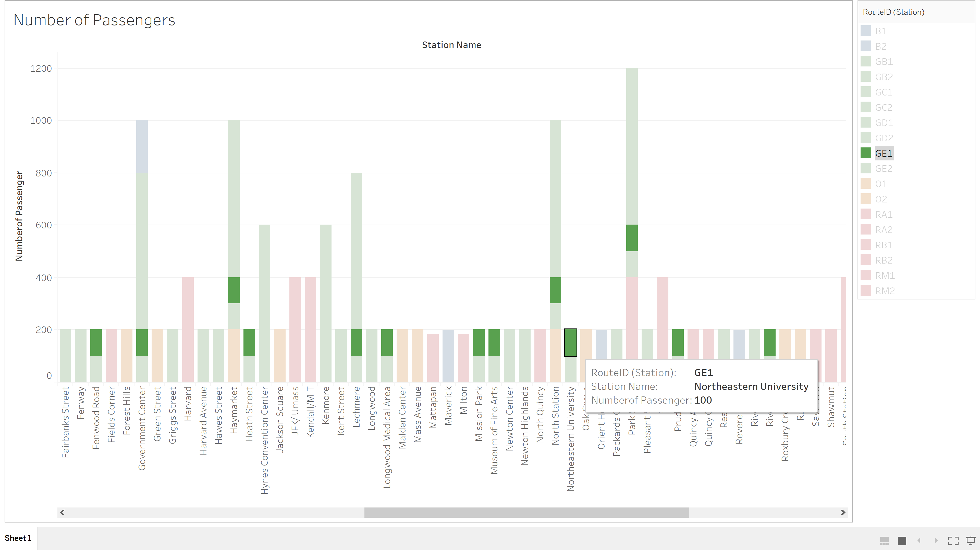

**-Data Points on a map** indicating details about : **Onboarding Passenger on a particular train, route, station, date and time**

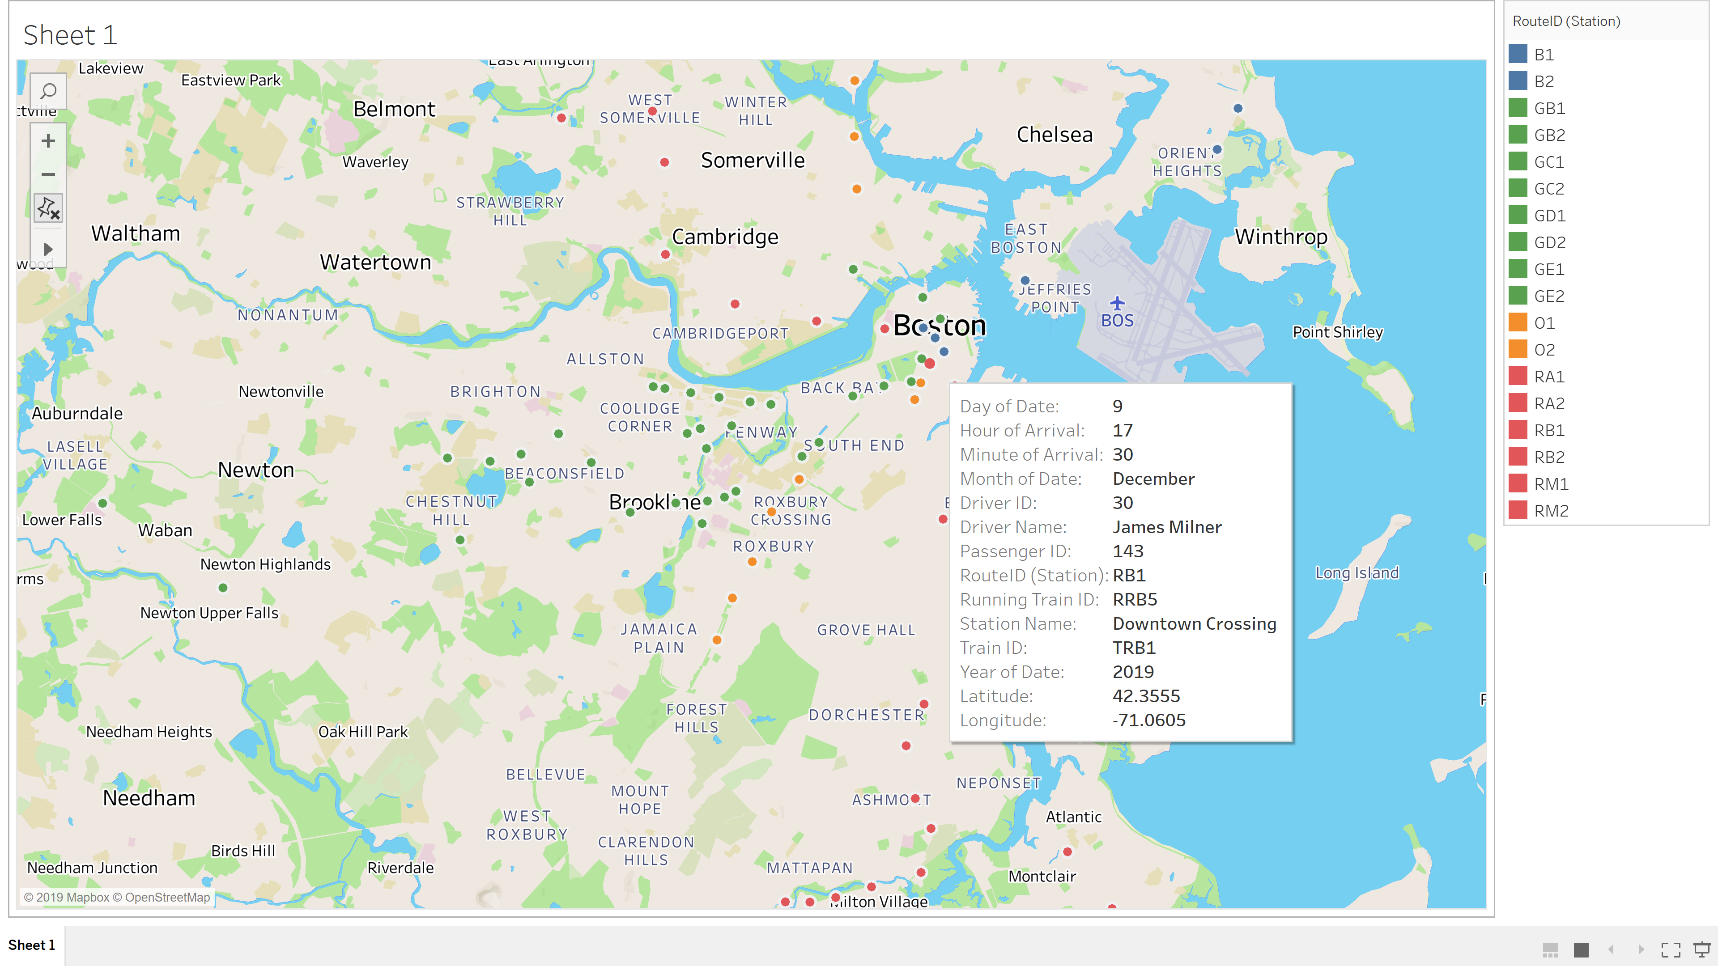

**-Data points on a map** indicating details about: **Onboarding passenger** on a **particular Route, Station, Date**

**-Size of the datapoint** represents the **number of onboarding passengers** at a **particular Station**

